Operating Systems Lab Assignment 3 -

Task1- Implement priority and round robin scheduling and calculate turn around time and waiting time.
Sol.- Priority scheduling
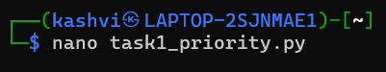
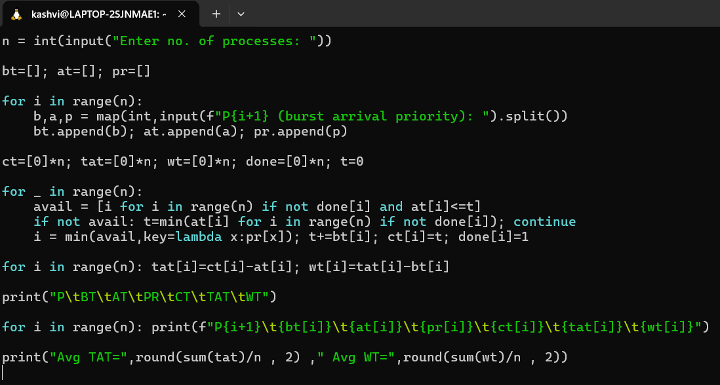
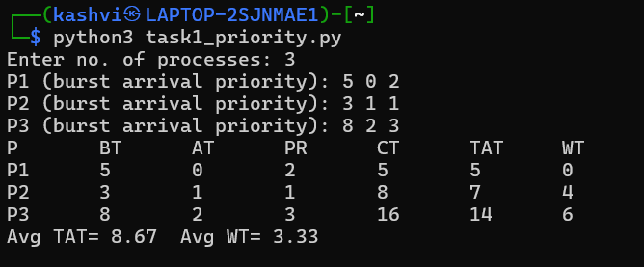

- Round Robin Scheduling
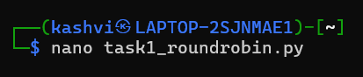
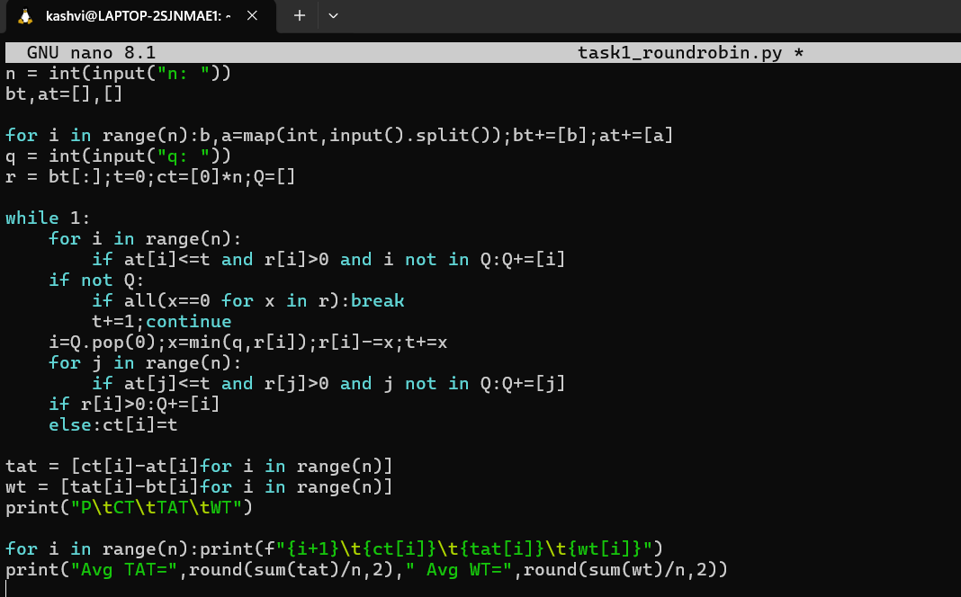
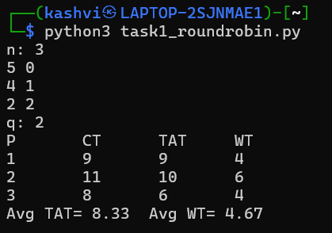

Task 2- Simulate worst-fit, best-fit, first-fit memory allocation strategies.
Sol.-
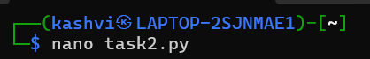
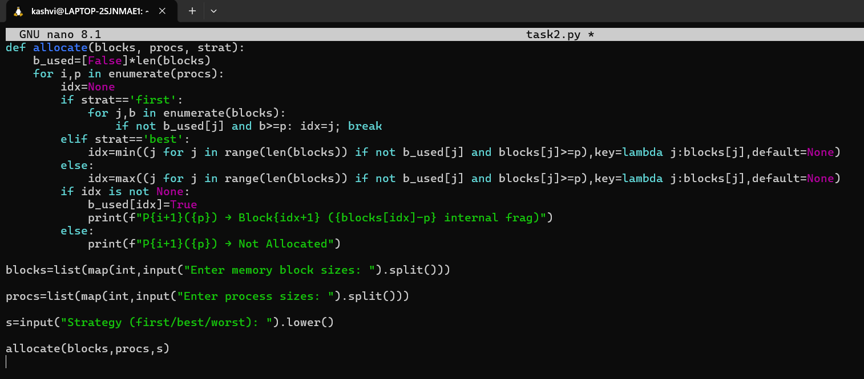
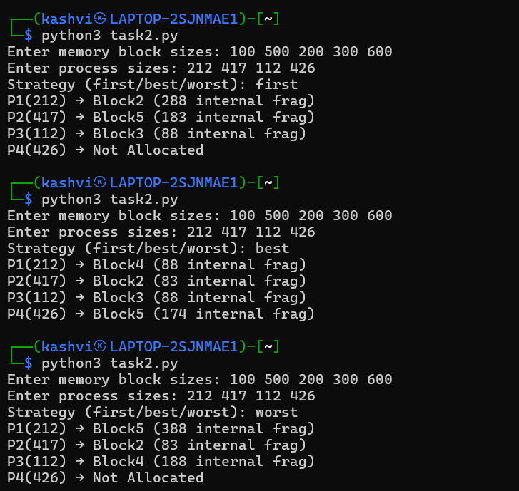

Task 3 - Implement MFT and MVT Memory Management
Sol.- MFT (fixed partition)
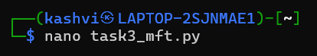
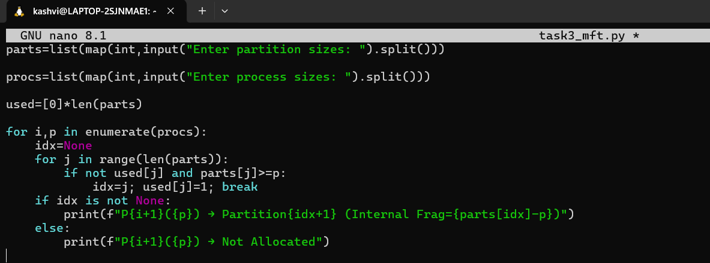
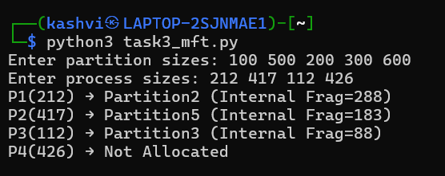

- MVT (variable partition)
